EPATHUSA.

PROCESS MANUAL – BUSINESS DEVELOPMENT

Issue No: 01 Date: September 15, 2017

Revision/Version: 1.0 Date: September 15, 2017

Approval Details

 | Prepared By | Issued & Controlled By | Approved By
Designation | Process expert team | Hari | Anitha

Copy Holders / File Access Authority

Sl. No | Designation | Authority
1 | Management Representative | RW
2 | Manager - BD | R

CONTENTS

Sl. No | Procedure Name | DOC No | Version Status
Sl. No | Procedure Name | DOC No | 0 | 1 | 2 | 3 | 4 | 5
 | QUALITY SYSTEM PROCEDURES
1 | QSP for Business Development | QSP/EPATHUSA/BD/01
2 | QSP for Customer Satisfaction Survey | QSP/EPATHUSA/BD/02
 | DOCUMENTS
 | FORMATS
3 | Contract Review Check List | QF/EPATHUSA/BD/01
4 | Project Initiation Form | QF/EPATHUSA/BD/02
5 | Customer Satisfaction Questionnaire | QF/EPATHUSA/BD/03

VERSION HISTORY

DCR No | Date | Nature of Change | Brief Reason for Change | Page / Section Where Changes Made | New Version No

Definitions and Acronyms

Acronym/ TErm | Definition/ Description
BD | Business Development
MD | Director
MGR | Manager
SDH | Solution Delivery Head

Activity / Responsibility Matrix

No | Activity | MD | MGR BD | SDH
01 | Generating the lead | i | r | I
02 | Making follow up calls |  | r
03 | Approving the prospect |  | r | R
04 | Preparation of estimation |  | I | R
05 | Approval of Quotation | R
06 | Contract Review | R | I | I
07 | Preparation of Project Initiation Note |  |  | R
08 | Response to Queries and Complaints |  | R | I
09 | Collecting Customer Feedback |  | R | I
R – Responsible; I - Involved

Purpose
To Ensure Business Development Team Generates Leads from various sources and convert them into prospective customers

Scope
Covers All calls made by business development team regarding organization services and projects

Entry Criteria
Leads Generated
Enquiry from Customers / Prospects

Exit Criteria
Contract Review
Submission of Quotation
Receipt of Order

Output
Project Initiation Note

Action & Method
(Refer Process Flow Diagram in Next Page)

References
Quality System Manual – QSM/EPATHUSA/01

Documents
Nil

Formats and Records
Contract Review Check List - QF/EPATHUSA/BD/01
Proposals Submitted
Customer Orders / Contracts
Project Initiation Note - QF/EPATHUSA/BD/02

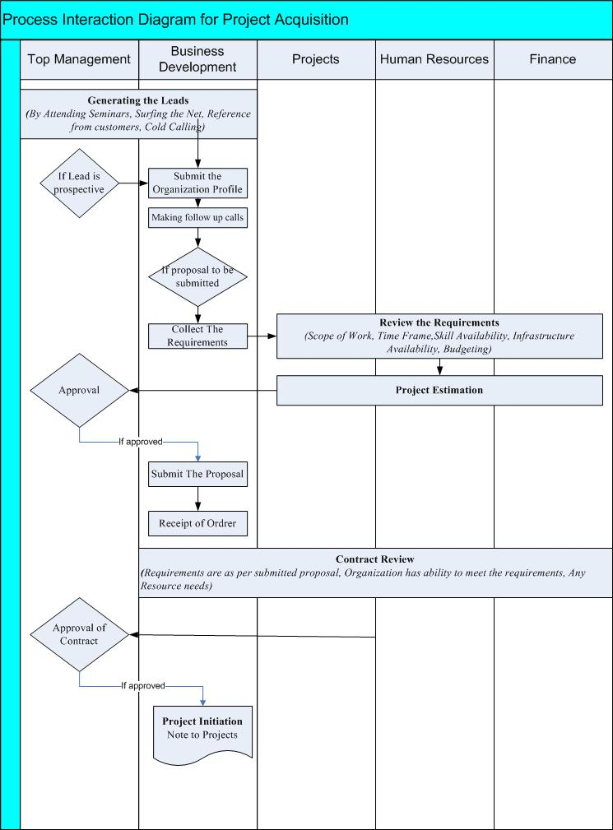

Purpose
To ensure customer feedback is collected every quarter or after completion of the project. This feedback is analyzed and reviewed for continual improvement.

Scope
This procedure covers all the customers of ongoing projects.

Entry Criteria
Completion of the quarter with the customer
Project completion

Exit Criteria
CSS agreed with the customer

Output
CSS (QF/EPATHUSA/BD/03) duly filled up by the customer

Action Method
- After every quarter or completion of each project, Customer Satisfaction Questionnaire (QF/EPATHUSA/BD/03) is sent to customer by seeking his / her feedback on organization performance during development
- Once filled questionnaire is received from customer, the SDH & Director reviews and takes appropriate actions for improvement if required
- The data is reviewed in management review meetings by Director.
- The corrective/ preventive actions are initiated in following cases
  - If overall rating is below 70%
  - If customer has given rating below 4 for any parameter in the report
  - Against suggestions given by customer
- A letter or mail shall be sent to customer describing action plan against his feedback if required.

References
Nil

Documents
Nil

Formats and Records

Customer Satisfaction Questionnaire – (QF/EPATHUSA/BD/03)

